**BMI SYSTEM OVERVIEW**

**BMI (Body Mass Index)** has been used for over 100 years in population studies, by doctors, personal trainers, and other health care professionals, when deciding whether their patients are overweight. However, [**BMI**](http://www.medicalnewstoday.com/info/obesity/what-is-bmi.php) has one important flaw - it does not measure your overall fat or lean tissue (muscle) content.  
  
Body Mass Index, derived from a simple math formula, was devised in the 1830s by Lambert Adolphe Jacques Quetelet (1796-1874), a Belgian astronomer, mathematician, statistician and sociologist. BMI is said to estimate how fat you are by dividing your weight in kilograms by your height in meters squared. However, as mentioned earlier, the measurement is flawed, especially if the person carries a lot of muscle.

The Body Mass Index(BMI) calculator is an application designed to run on Android platform.

If you want or have to do loose weight, the first thing to do is weigh yourself. Are you too heavy? By how much?

The BMI calculator will be used to help you determine that irrespective of age and gender.

Although you BMI does not actually “measure” your percentage of body fat. It is a useful tool to estimate a healthy weight based on your height,it also helps professionals to access risk of chronic diseases.

**Advantages of BMI**

BMI is generally considered the best way to determine if an individual is at a healthy weight. Using BMI is popular because it is simple, quick, effective and applies to adult men and women, as well as children. BMI is a useful tool for quickly assessing weight classification. While it does not directly measure body fat, it is more accurate at approximating degree of body fatness than weight alone. In addition, you do not have to be of an exact weight or measurement, to be considered 'normal.' There is a range within each classification to allow for different body types and shapes. For example, you can be 10 to 15 pounds heavier than a same height counterpart and still fall within a normal weight range.

**Disadvantages of BMI**

BMI has limitations. Because it is not a measure of body fatness, very muscular individuals often fall into the overweight category when they are not overly fat. Additionally, BMI may place individuals who have lost muscle into the healthy weight category. Measuring BMI for very short people or pregnant women is not appropriate. It is believed that excessive abdominal fat is more health threatening than hip or thigh fat. A woman with a waist circumference greater than 35 inches and a man with a waist circumference of greater than 40 inches may be at an increased risk for developing high blood pressure, stroke and heart disease. Therefore, the National Institute of Health (NIH) has asked physicians to measure patients' waistlines.

**SYSTEM ANALYSIS**

This system compares your body weight to your height and it is calculated by dividing your weight in kilogram (kg) by your height in meters square (m^2).

BMI = body weight in kilogram (kg) divided by height in meters square

* Xkg/(Ym *Ym)
* Where X = body weight in kg

Y = height in meters

The user of this system will be able to maintain a healthy weight range for his/her height.

SYSTEM DESIGN

**BMI CALCULATOR**

Weight(in Kg)

Height(in meters)

**CALCULATE**

IMPLEMENTATION

INPUT DATA

* Body weight
* Height

OUTPUT

* BMI

USER INTERFACE(GUI)

The interface of this system is designed using Android Studio tools which includes Scroll Layout and Linear Layout

* Background image
* TextViews
* EditViews
* Button

CODING

* XML
* Strings
* Java

FLOW CHART

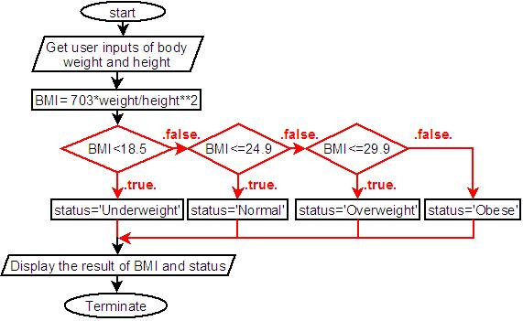

SUMMARY

In summary,the BMI calculator is a tool designed to help you stay fit and healthy.